WEST LONDON WASTE AUTHORITY
Report of the Managing Director | 22 September 2023
WLWA Business Plan 2023-24

SUMMARY
This report provides details of the strategic priorities that form the basis for the Authority’s Business Plan for 2022/23. The key points are:
- Legislative delay represents a financial risk to WLWA and Boroughs if we are not ready to meet the carbon taxes that the Emissions Trading Scheme represents to Local Authorities. Detailed in Appendix 1
- The risk will be managed using the existing JMWMS framework for waste agreed with Boroughs in March 2022 and the strategic priorities.
- Employees and stakeholder feedback was good but with very clear recommendations to improve clarity and capacity. The action plan is detailed in section 4 and has informed the improvements to strategic priority 5 Organisational Excellence.
- The annual strategic priorities have been reviewed and aligned with the environment directors’ priorities and the six joint WLWA and Borough waste policies. The budgeted programmes are delivering on priorities 1-4 this year but are complex to deliver and report. Aligning Borough budget savings next year with programmes will reduce some of this complexity.
RECOMMENDATION(S)
The Authority is asked to:-
- Note the shared financial risk posed by the emissions trading scheme and encourage Borough Environment Directors and Finance Directors to engage in early budget savings discussions with WLWA to inform 2024-25 budget setting, priorities and programmes.
- Approve the action plan resulting from the employees engagement survey in section 4
- Approve the changes to strategic priority 5 Organisational Excellence.
- Note the accountability and responsibilities for each of the 2023 Strategic Priorities in Appendix 1.
- Background
Since 2019, the Joint Municipal Waste Management Plan and consequently the West London Waste Authority business plan has focused on outcomes and joint working whilst we wait for clarity on environmental legislation and waste regulations.
- Introduction
This report provides an update on the WLWA 2023-24 Business Plan and the strategic priorities agreed in the June meeting.

- Roll over from the 2022-23 Business Plan
Due to confirmation of further legislative delays, the Joint Plan for 2030, Infrastructure Investment Plan, and Extended Producer Responsibility Strategy will be removed from the annual plan and will be reconsidered once the legislation is clear.
Appendix 1 details the financial risk posed by the emissions trading scheme. This risk is exacerbated by the delays to waste regulations following the Environment Act 2021. To manage the risk, WLWA is using the existing Joint Municipal Waste Management Strategy (JMWMS) framework agreed with Boroughs in March 2022. More detail is provided in section 7 of this report – Financial Implications.
The HR strategy will be addressed in HR update reports.
- Feedback from the Employees engagement survey
The feedback from the Employees engagement survey in June was:
WLWA is a high performing team but intervention is necessary to prevent slippage.
- 55% of indicators are 8/10 or above, 45% of indicators are 7/10 or above, 0 indicators are below 7/10, however:
  - A proportion (~16%) of the organisation are showing signs of being disengaged. Almost all of these are in leadership or management roles.
  - Resourcing, roles and responsibilities and team (trust) should be addressed.
- Employees across the organisation perceive WLWA to be a diverse and inclusive workplace today.
- Diversity and inclusion both scored an average 8/10 from the employee’s perspective, however:
  - A proportion (potentially as many as a third) of the organisation has reported being on the receiving end of discriminatory behaviour.
The recommendations and actions are shown in the table below.

Recommendation | Action | Date
CULTURE
Put specific emphasis on changing the climate by tackling resource issues (where able to) and creating something for people to enjoy (e.g. a positive company-enhancing event such as team building). | Consider resources during Budget setting for 2024-25  Half day sports day event.  Inclusive Team Meeting with Abbey Road Ops. | By Mid Nov 2023  Complete DATE  Planned DATE
Reset what the culture needs to be and bake it into systems and processes that mean people are held accountable for doing their bit.  Address the rise in control and its opposing nature to the company values. | Include governance in Strategic priority 5 Organisational Excellence  Review / implement formal and informal governance improvements.  SLT commitment to Managers to set clear objectives and measures and stick to them. | Complete  5 Sept 2023  1 Oct 2023 – 31 Mar 2024  Complete  5 Sept 2023
LEADERSHIP
Complete a comprehensive 360 on all leaders and managers where honest and candid feedback is provided about each other and over whether people are behaving in accordance with the company values. | Two away days for Managers and Leaders resetting what the culture needs to be.  Review Leadership and Management structure  Comprehensive 360 | 4-5 Sept 2023  By end Dec 2023  By 31 March 2024
CLARITY
Run a workshop with middle managers to understand where role / responsibility / accountability confusion lies and to identify where greater clarity is needed. | Two away days  Strategic priorities reviewed  Clear accountability and responsibility for delivery of the strategic priorities created. | Complete  4-5 Sept 2023
Run a workshop with employees to understand how the organisation can become more ‘people centric’ in their eyes again. In doing so, explore what’s missing from a career progression and growth perspective for people. | Plan using lessons learned from the Leaders and Managers away days and the DEI training initiative. | TBC  By 31 March 2024
DIVERSITY
Run a DEI training initiative and look to discover more about the incidents that may have led to people feeling like they have been on the receiving end of discriminatory behaviour | Suitable training organisation identified  Planning call diarised  Training initiative and feedback | Complete  DATE  DATE TBC

- Feedback from the Stakeholder engagement survey
The headlines from the stakeholder engagement survey in July/August are:
- A really good organisation
  - Transformed from what it once was
  - Very strong leader
  - Strong leaders who are showing growth
  - Strong relationships with strong performers in wider team / management team
- An organisation going through change – we sense a little of your recent disruption
  - Questions over whether WLWA has become too focussed on broader agendas and lost sight of core business (waste).
  - A team that is stretched beyond its natural capacity
Stakeholders provided some excellent ideas for improvement which will be considered further as the strategic priorities are updated this year and for next year.

- 2023-24 Strategic Priorities updates
It was reported to the June Authority that using five strategic priorities we will start to invest in and initiate the change of our waste management model. The lessons learned from the 2022-23 Business Plan identified the need for single point accountability, and for business planning timing to pull forward six months to inform budget planning 2024-25.
Feedback from the employee engagement survey and stakeholder survey has been used to strengthen Strategic Priority 5 Organisational Excellence in year with clear objectives and measures to invest in and initiate improvements in people, systems and governance.
Priorities 1-4 are being delivered by the budgeted programmes for the remainder of this year and will be reported by the Projects Director.
The Finance Director post has been deleted, the Finance Manager is now in SLT and responsibility for people, systems and governance has been reallocated across SLT under interim management arrangements. The structure of management is also being reviewed.
Financial monitoring of the programmes has demonstrated the complexity of reporting WLWA investment and Borough savings. To mitigate this and create simplicity WLWA has offered early collaborative budget savings meetings to all Boroughs to align Borough budget savings with WLWA programmes where possible.
Need identified | Progress
Each priority to have single point accountability at a senior level in the organisation. | Complete 5 Sept 2023
Business planning to pull forward by six months to inform budget planning 2024-25. | Started.  Target completion, Oct 2023
Improve Strategic Priority 5 Organisational Excellence in year. | Complete 5 Sept 2023
Restructure senior leadership team. | Started.  Target completion Oct 2023
Review Management structure. | Target completion Dec 2023
Offer budget savings meetings to all Boroughs | Two meetings diarised.  Target completion Oct 2023
The strategic priorities, detailing accountability and responsibility is shown in section 11.
The improvements to Strategic Priority 5 Organisation Excellence for the next six months is detailed in Appendix 2.
- Financial Implications
The cost risk of the emissions trading scheme will take effect from 2028 and is expected to be substantial risk. It is difficult to calculate and, being based upon a market approach will be difficult to predict year on year. The working cost assumption for now is c. £36 per tonne or up to £3m per Borough. This assumption will continue to be reviewed as modelling work takes place and an industry consensus emerges.
Legislative clarity is required before WLWA and the six constituent Boroughs can agree a joint plan. The JMWMS framework agreed in March 2022 uses a waste reduction / circular economy / decarbonisation approach to mitigate the risk of overspending whilst targets are unfunded or unsupported by legislation by using:
- the co-benefits of addressing ETS and reducing cost by reducing waste,
- £1m invested in funded programmes for this 2023-24 Business Plan to create alignment with carbon savings and Borough financial savings.
- internal improvements to support the direction of travel created by the programmes in Strategic Priority 5 Organisational Excellence.
Costs associated with the updates and changes are:
- Already budgeted:
  - Wellbeing sports day half day
  - The employee engagement survey and stakeholder engagement surveys.
  - The waste composition analysis.
  - Three posts deemed to directly support Strategic priority 5 Organisational Excellence.
  - £1m investment with expected savings
- Mitigated
  - The costs associated with restructuring will be partly offset by the deletion of the Finance Director post.
- Additional
  - £2,500 spent on the Leaders and Managers two away days
  - Diversity, equality and inclusion workshop - £TBC <£5,000
  - People centric workshop with employees - £TBC < £5,000
The programmes spending is below budget. The expected savings are being delivered direct to Boroughs and are as expected at the half year point. Detail on the programme savings will be reported regularly by the Projects Director.
- Risk Management
Leaders and Managers will review and update risk item 3 in the risk register as part of strategic priority 5 Organisation Excellence.
- Legal Implications
The Regulations to follow the Environment Act 2021 are further delayed. This creates confusion for an organisation such as WLWA which wants to support individual Boroughs as best it can but has no clarity of funding, legislative support or targets.
- Impact upon the Environment Directors priorities
The strategic priorities in the business plan deliver on the Environment Directors priorities agreed in September 2022.

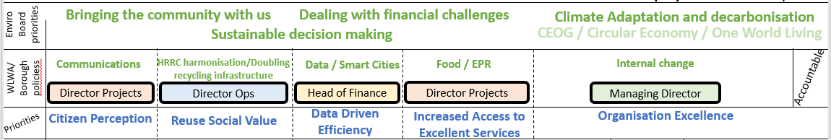

- Impact on Joint Municipal Waste Management Strategy
The business plan will deliver on the framework agreed in March 2022.
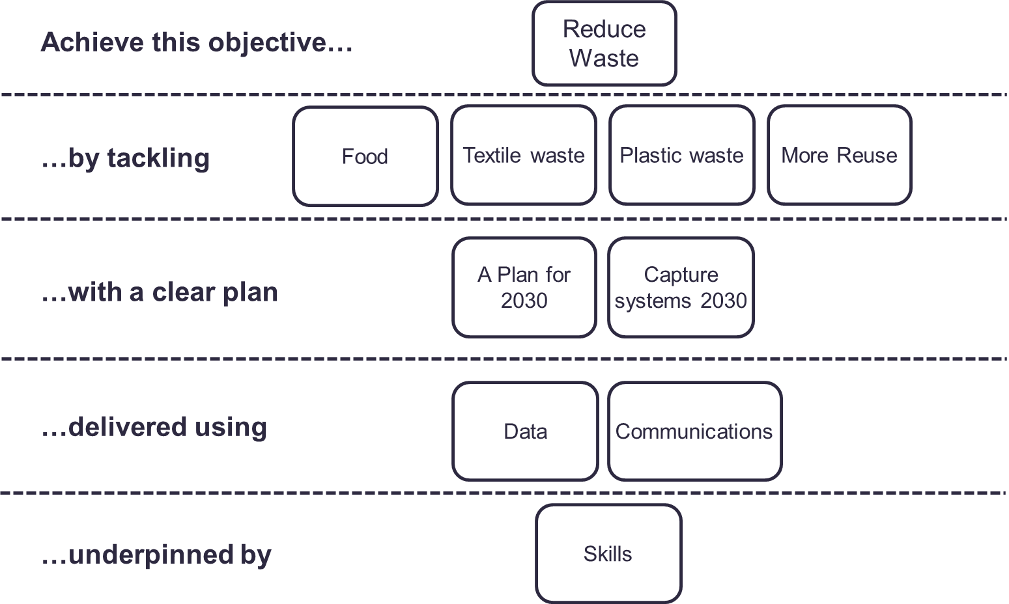

- Impact upon Carbon reduction
The JMWMS framework agreed in March 2022 uses a waste reduction / circular economy / decarbonisation approach to mitigate the risk of overspending. This has the co-benefit of promoting carbon reduction measured as the carbon embedded in waste.

WLWA 2022 Waste Composition Analysis
Tonnes CO2eq
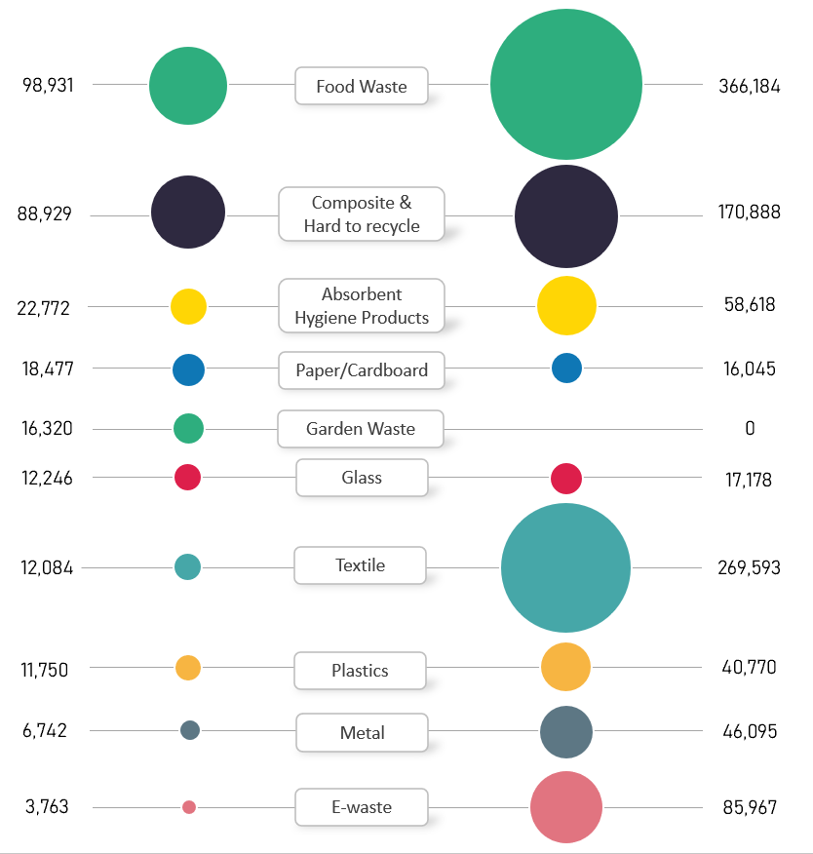

Background Papers
 | Emma Beal | Managing Director | 07766 147 978
 |  | emmabeal@westlondonwaste.gov.uk

